**Category wise number of articles in each family**

**using Stacked column chat**

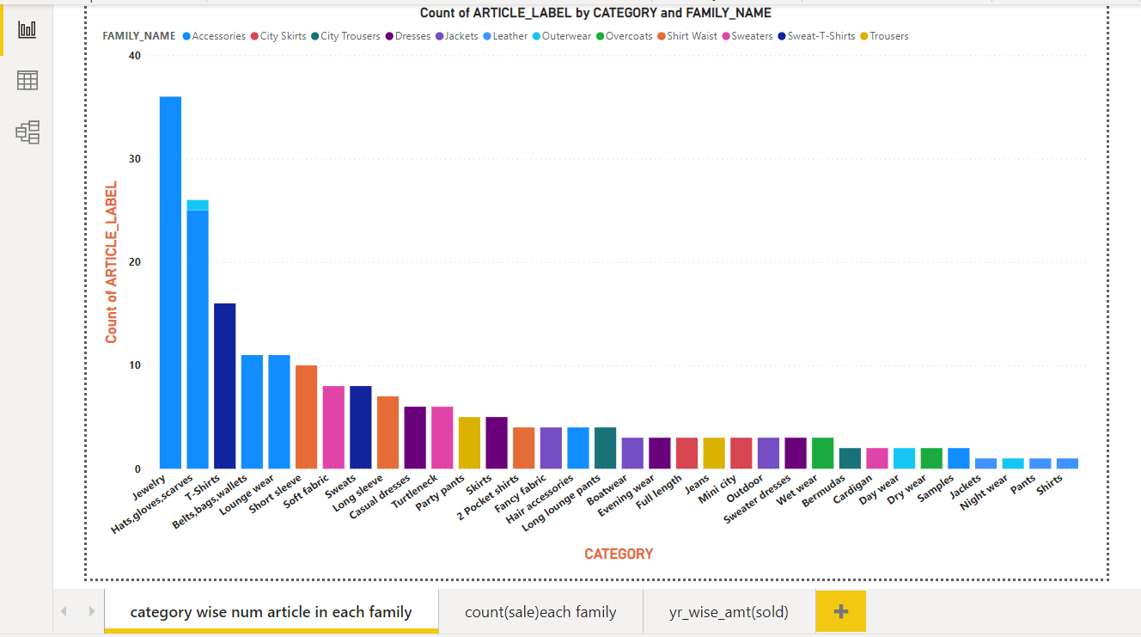

**Number of sales in each family**

**using Donut chat, Stacked column chat, Table chat, funnel chart representation**

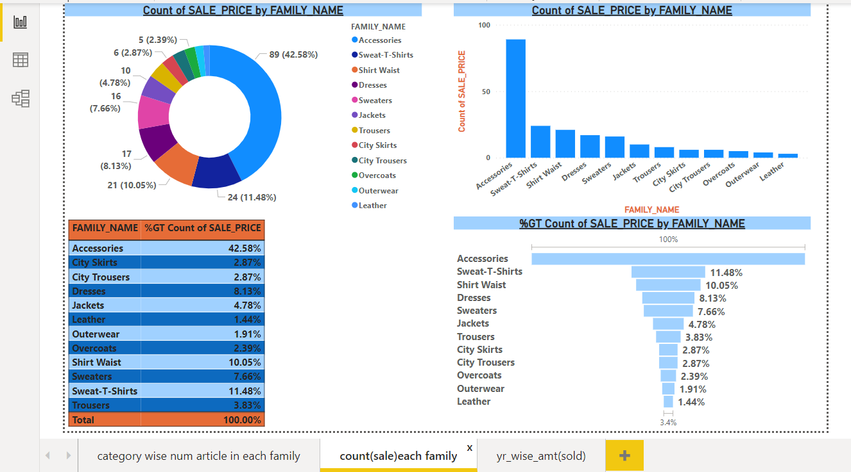

**Number of article in each category**

**using Pie chat, Stacked column chat, Table chat, Line chart representation**

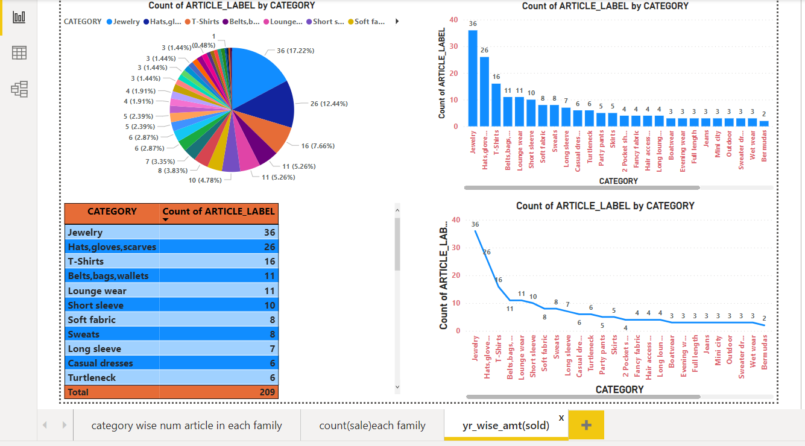

**Number of article in each city**

**using tree map**

